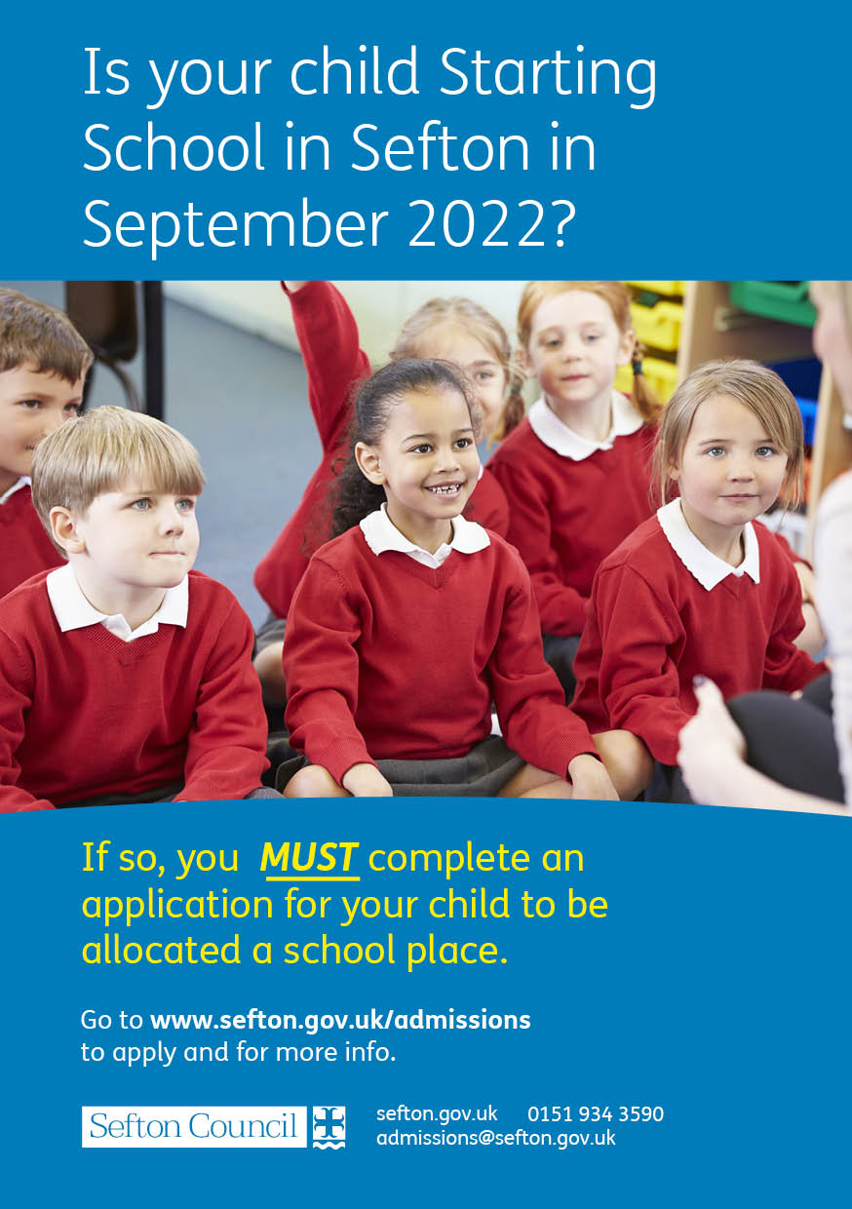

Starting Primary School in
Sefton – September 2022

When will my child start school?
Most children start primary school in the September following their fourth birthday. For further information please go to Sefton’s website at
www.sefton.gov.uk/admissions
- If your child was born between 1 September 2017 and
31 August 2018, they will normally start school in September 2022.

By law, all children must begin full-time education by the beginning of the term following their fifth birthday.

Where do I get further information about schools?
- Go to www.sefton.gov.uk/schools-learning/find-a-school
- Look at the school’s individual website;
- Contact the school you are interested in for more information.
- Read the booklets School Admissions - A Guide for Parents and School Admissions Information which are published on the Sefton website.
How do I apply for a place?
The quickest and easiest way is to apply online from
1 September 2021 by logging onto the Citizen Portal via the Sefton website at:
www.sefton.gov.uk/admissions
The Citizen Portal is simple to use and accesible on all devices including mobile phones. Complete the application carefully, stating up to three school preferences in the order in which you prefer them..

Please note: if you are applying for a Voluntary Aided School (e.g. Catholic & some Church of England Schools), you will need to complete a Supplementary Faith Information form in addition to the above. Please contact the preferred school(s) directly for details.

If you do not have access to the internet, you can contact Sefton Admissions Team to request a paper application form. If you complete a paper application, you must return the form to your first preferred primary school as soon as possible. You must also obtain a receipt from the school when submitting the form.
Important Information
Separate Admission Arrangements apply for entry into ALL Reception classes. You MUST still complete an admission application even if:

- you already have an older child attending the school, or
- the child already attends the nursery attached to a school, or
- you have already put your child’s name down at the school (an expression of interest)..

When do I apply for a place?
Applications open on 1st September. You must submit your application by 15 January 2022.

What if I apply late?
After 15 January 2022, your application may be treated as late. These applications may only be dealt with after national offer day on 19 April 2022. This may affect whether a place can be offered at your preferred school. For further information please read the published information guides.

What if I don’t get a place at my preferred school?
We try to offer the school you prefer but if this is not possible, you have the right to appeal to an independent appeal panel. Further information can be found in our School Admissions Information Guides which are both available on the Sefton website.

Moving house
If you change address after you have submitted your Admission Application, you must inform Sefton Admissions Team.

Apply for a school place online at
www.sefton.gov.uk/admissions

The National Closing Date is:
15 January 2022

Contact:
Sefton Admissions Team
Bootle Town Hall
Oriel Road
Bootle
L20 7AE
Email: admissions@sefton.gov.uk
Tel: 0151 934 3590

If you need this leaflet in a different format or another language, please contact us.

