Maths
basic skills

Name: ______________________________________

Date………………………

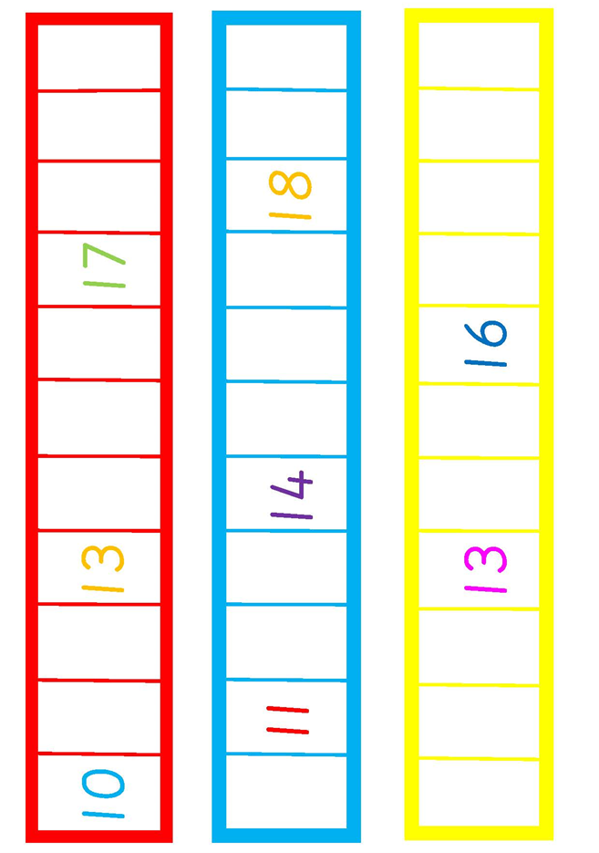
Date………………………

Date………………………

Date………………………

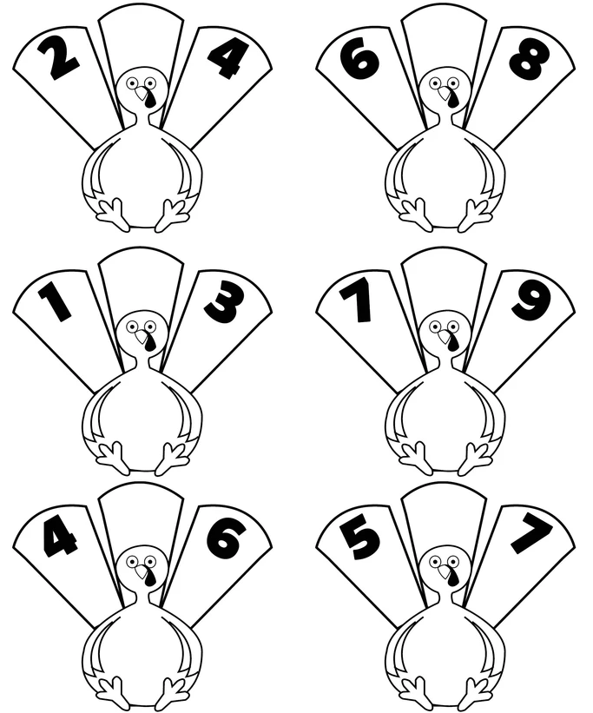
Date………………………

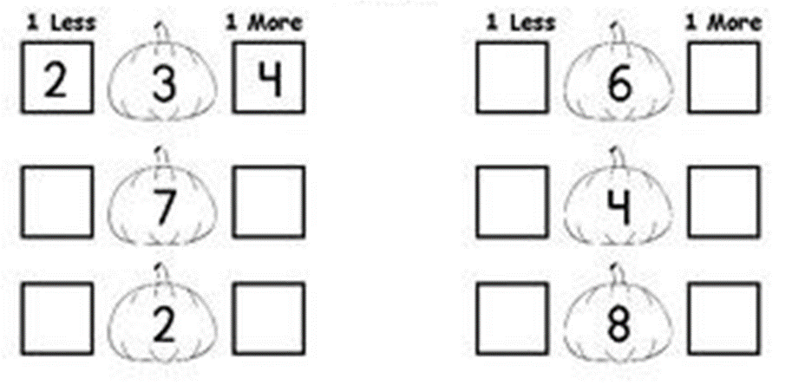
Date………………………

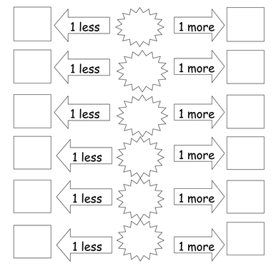
Date………………………
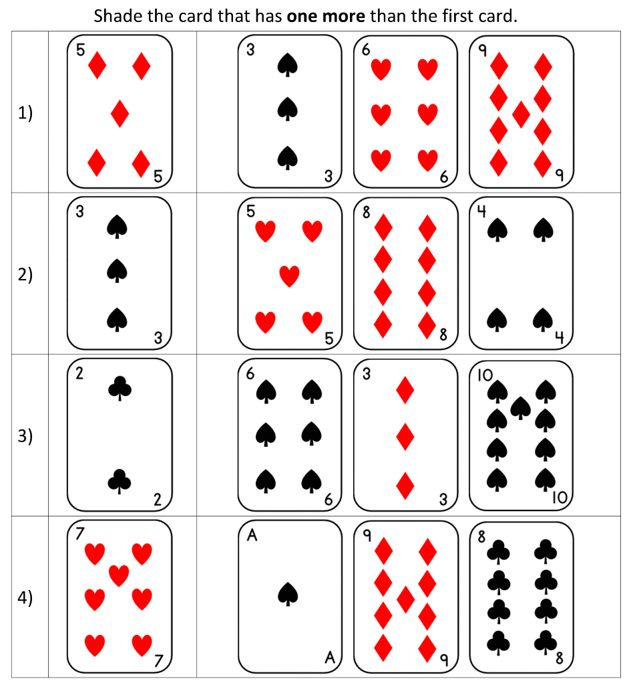

Date………………………
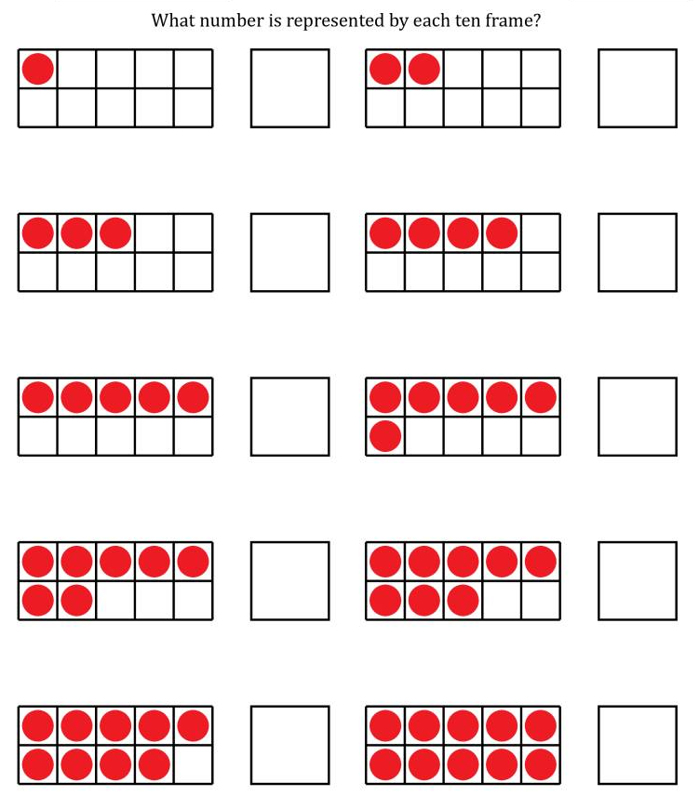

Date………………………
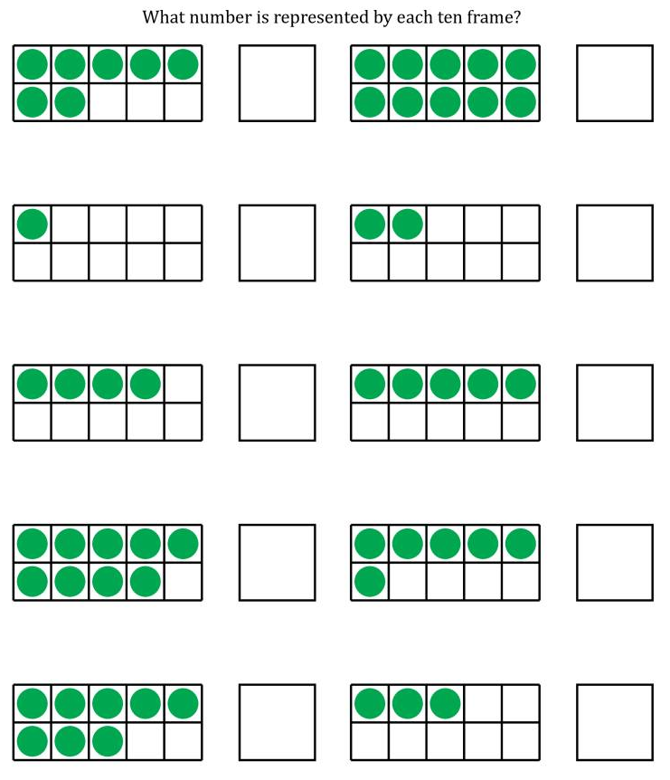
Date………………………

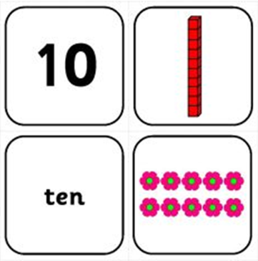
What number is being represented?

Now, can you try and represent these numbers?
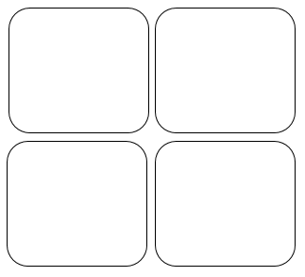
7
16

Date………………………

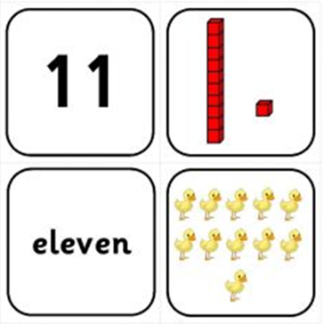
What number is being represented?

Now, can you try and represent these numbers?
9
12

Date………………………
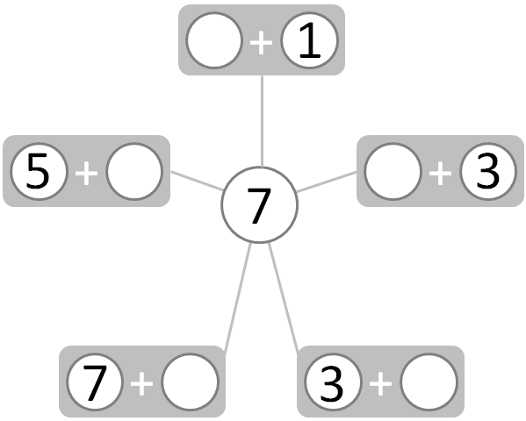

Date………………………
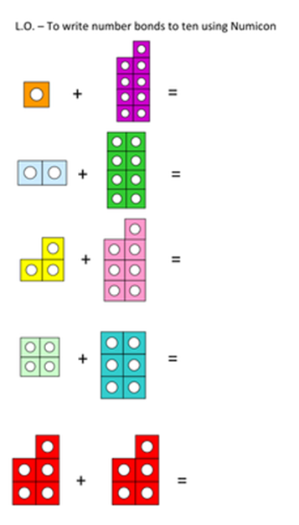

Date………………………

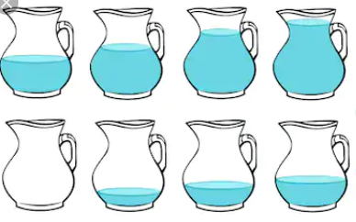
Circle the jug that is full Circle the jug that is empty

Circle the jug that is half full Circle the jug that is nearly empty

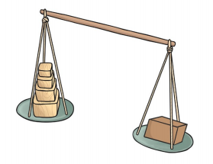
Circle the side that is heavier Circle the side that is lighter
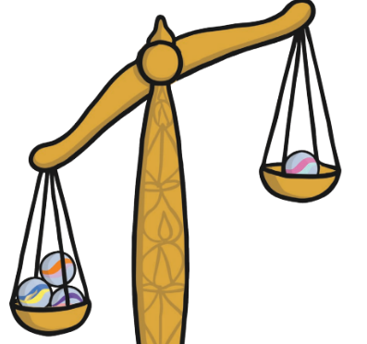

Date………………………

Follow the instructions to draw tall, short and long lines. Remember to use a ruler.

Draw a shorter line underneath this one.

Draw a longer line underneath this one.

Draw a taller line next to this one.

Draw a shorter line next to this one.

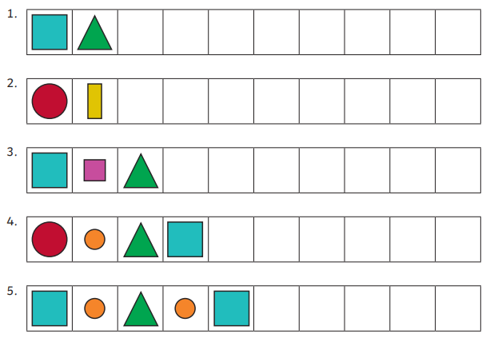
Date………………………
Date………………………
