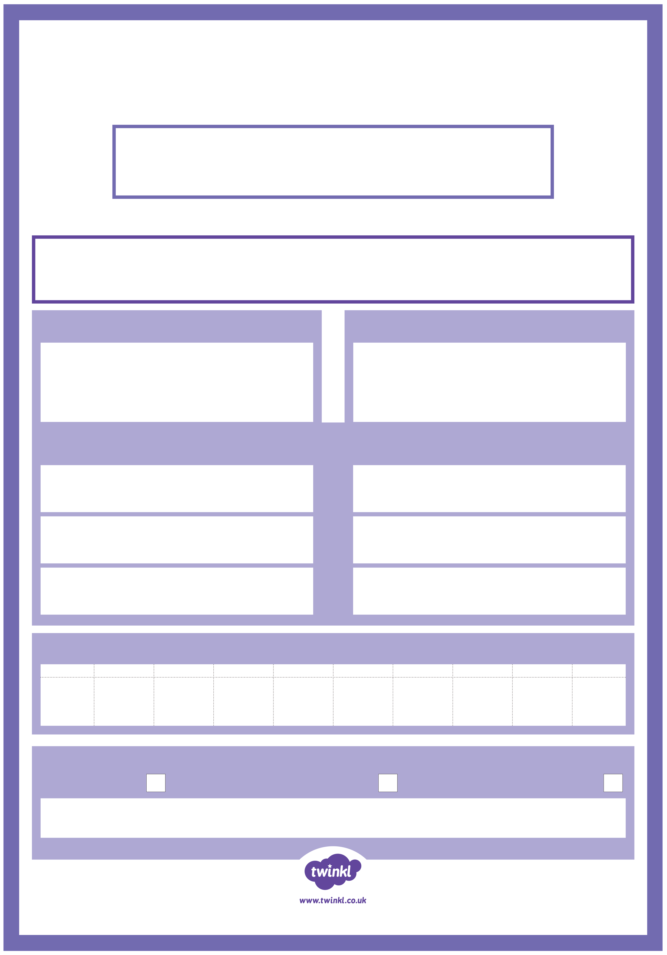

Number of the Day
Write the number in words.
Halve it!
Double it!
Three even numbers before it.
Three odd numbers after it.
Partition it!
Round it!
Nearest 10
Nearest 100

