Name: _________________________________________
Date______________________
LO: To tell the time to the hour and the half hour

Write the time under each clock.
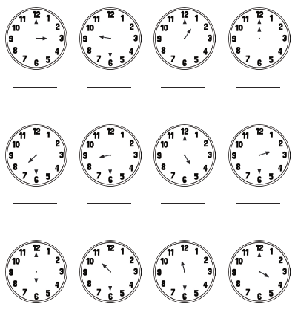

Name: _________________________________________
Date______________________
LO: To tell the time to the hour and the half hour

Draw the correct hands on the clocks below.
