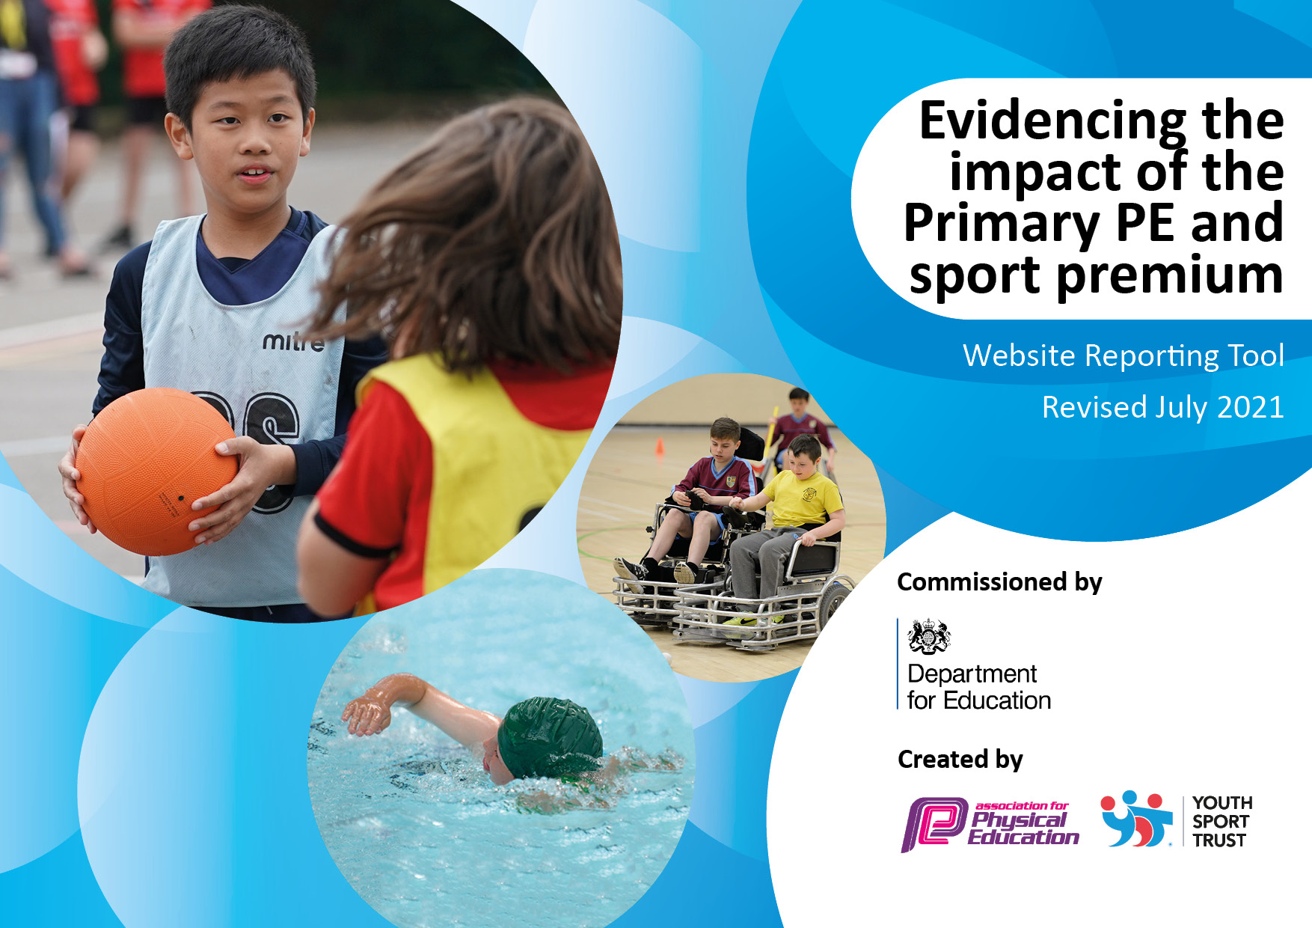
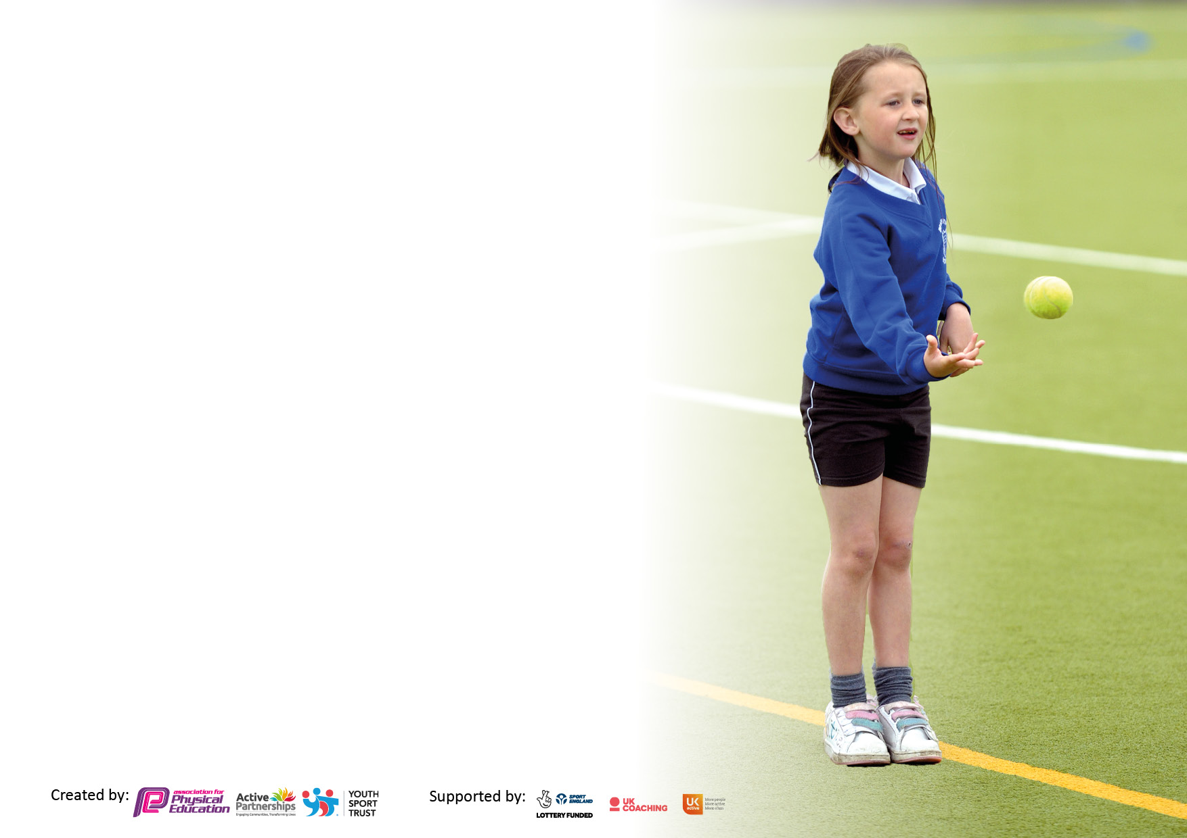

It is important that your grant is used effectively and based on school need. The Education Inspection Framework makes clear there will be a focus on ‘whether leaders and those responsible for governors all understand their respective roles and perform these in a way that enhances the effectiveness of the school’.
Under the Quality of Education Ofsted inspectors consider:
Intent - Curriculum design, coverage and appropriateness
Implementation - Curriculum delivery, Teaching (pedagogy) and Assessment
Impact - Attainment and progress
To assist schools with common transferable language this template has been developed to utilise the same
three headings which should make your plans easily transferable between working documents.
Schools must use the funding to make additional and sustainable improvements to
the quality of Physical Education, School Sport and Physical Activity (PESSPA) they
offer. This means that you should use the Primary PE and sport premium to:

- Develop or add to the PESSPA activities that your school already offer
- Build capacity and capability within the school to ensure that improvements made now will benefit pupils joining the school in future years
- The Primary PE and sport premium should not be used to fund capital spend projects; the school’s budget should fund these.
Please visitgov.ukfortherevisedDfEguidanceincludingthe5keyindicatorsacrosswhichschoolsshoulddemonstrate an improvement. This document will help you to review your provision and to report your spend. DfE encourages schools to use this template as an effective way of meeting the reporting requirements of the Primary PE and sport premium. We recommend you start by reflecting on the impact of current provision and reviewing the previous spend.
Schools are required to publish details of how they spend this funding, including any under-spend from 2019/2020, as well as on the impact it has on pupils’ PE and sport participation and attainment. All funding must be spent by 31st July 2022.
We recommend regularly updating the table and publishing it on your website throughout the year. This evidences your ongoing self-evaluation of how you are using the funding to secure maximum, sustainable impact. Final copy must be posted on your website by the end of the academic year and no later than the 31st July 2021. To see an example of how to complete the table please click HERE.
Created by: Supported by:

Details with regard to funding
Please complete the table below.
Total amount carried over from 2019/20 | £300
Total amount allocated for 2020/21 | £20,450
How much (if any) do you intend to carry over from this total fund into 2021/22? | £1,300
Total amount allocated for 2021/22 | £20,554 (estimated)
Total amount of funding for 2021/22. To be spent and reported on by 31st July 2022. | ££20,554 (estimated)
Swimming Data
Please report on your Swimming Data below.

Meeting national curriculum requirements for swimming and water safety.
What percentage of your current Year 6 cohort swim competently, confidently and proficiently over a distance of at least 25 metres?  N.B. Even though your pupils may swim in another year please report on their attainment on leaving primary school at the end of the summer term 2020. | 70%
What percentage of your current Year 6 cohort use a range of strokes effectively [for example, front crawl, backstroke and breaststroke]?  Please see note above | 10m front and back 72%  25m front and back 64%  25m front, back and breaststroke 38%
What percentage of your current Year 6 cohort perform safe self-rescue in different water-based situations? | 66%
Schools can choose to use the Primary PE and sport premium to provide additional provision for swimming but this must be for activity over and above the national curriculum requirements. Have you used it in this way? | No

Action Plan and Budget Tracking
Capture your intended annual spend against the 5 key indicators. Clarify the success criteria and evidence of impact that you intend to measure to evaluate for pupils today and for the future.

Academic Year: 2020/21 | Total fund allocated: £20,450 | Date Updated: 31st July 2021
Key indicator 1: The engagement of all pupils in regular physical activity – Chief Medical Officers guidelines recommend that primary school pupils undertake at least 30 minutes of physical activity a day in school |  |  |  | Percentage of total allocation:
 |  |  |  | 25%
Intent | Implementation |  | Impact
Your school focus should be clear what you want the pupils to know and be able to do and about  what they need to learn and to  consolidate through practice: | Make sure your actions to achieve are linked to your intentions: | Funding allocated: | Evidence of impact: what do pupils now know and what can they now do? What has changed? | Sustainability and suggested next steps:
Improve fitness levels and stamina of pupils and provide a minimum of 30 minutes physical activity at school | Re-introduction of Golden Mile  Initiative – including baseline test of  all 19 classes in Autumn and  Summer, access to the system to record and log miles and training for Y5 Golden Mile leaders.  Class teachers built in time each week for daily mile sessions, appropriate to the age of the pupils.  Participation in Santa Dash organised by North Sefton Games Organiser.  Norwood’s Cancer Research Race for Life completed in Summer term.  Norwood’s Internal Cross Country Championships extended to include Reception and KS1 children  KS2 took part in the virtual Sefton One Mile Cross Country Championships | £1350 | Children can see the improvement in their own fitness levels and ability to run more laps of the track.  Children had at least 2 opportunities a week to run their Golden Mile and were encouraged to run or walk fast.  Certificates were announced in virtual Star of the Week.  All children took part in Santa Dash.  Race for Life raised over £14,000 with all children and staff participating.  Virtually all children across all year groups including children with mobility needs participated or competed in the Cross Country championships with Gold, Silver and Bronze medals awarded to the Top 3, certificates for the Top 10 and certificates for competing the course.  All KS2 children participated in the timed one mile run and the top 4 times were sent to Southport Waterloo Athletic Club with Norwood having an individual winner and 2 individual placings, a year group winner and placing and finishing 2nd overall. | Increase number of assessment points during the year to track children and identify extra support needed.  Post COVID restrictions being removed, train Year 5 children to be Golden Mile Leaders and lead organisation of the programme.  Increase number of opportunities to complete Golden Mile from 2 to 3 times a week.  Arrange another whole school running event – linking to London Marathon.  Continue with extension of internal Cross Country Championships to whole school.
 | PE subject leaders shared North Sefton virtual challenges with staff and PE specialist teacher. Children given the opportunity to practise these during the school week. | None | All virtual challenges shared by Kate Alyson, North Sefton Sports Games Organiser were attempted by children from Year R through to Year 6 every half term with the results of each year groups winner celebrated in Star of the Week and the newsletter.  Results were shared with the organiser and a number of children from Norwood were successful in winning the overall North Sefton competitions. | Continue to include Virtual Challenges internally as competitions and make the challenges available at playtimes for children to practise.
 | Trained Year 6 and Year 5 Physical Activity Leaders to deliver Structured Lunchtime Play for KS1 pupils and purchase additional and specific equipment.  Member of PE team received training alongside in order to be the Lead MDS for Lunchtime sessions. | £200  for Physical Activity Leader  T shirts and caps  £200  for Trainer  costs including 3 half days  training  £300  additional play equipment | 70 children across Year 5 and Year 6 were trained and developed their leadership skills.  Because of COVID restrictions and year group bubbles, they were only able to promote active playgrounds and increase activity levels for their own year groups.  Feedback from PALs and staff showed a pride in their role, self esteem improved and aspiration for future Sports Leadership at High School.  Sports MDS organised rota to ensure there were opportunities for pupils and suitable equipment. | Year 5 will continue to fulfil roles as Physical Activity leaders with EYFS and KS1 during lunchtimes in September if COVID restrictions are removed.  Current Year 4 children to receive their training in September.  Sports MDS to be solely responsible for lunchtime PAL sessions.  Storage and equipment audit has identified more need specifically for this group.
 | Purchase of new playground equipment for each Year group for use at break time and lunchtime including storage | £1,000  including storage | Due to COVID restrictions, more equipment was needed as there was insufficient equipment/resources for sharing and cleaning. | Children have enjoyed having their own equipment and so this will need to be replenished and updated.
 | Purchase of new lunchtime field equipment including storage | £500  including storage | Due to COVID restrictions, more equipment was needed as there was insufficient equipment/resources for sharing and cleaning as children were encouraged to access more outdoor spaces to ensure bubbles remained separate. | Children have enjoyed being on the field more and therefore having specific equipment/resources for sole use on the field and so this will need to be replenished and updated.
 | Increase the number of children participating in physical active extra-curricular clubs | £1,250  Part payment by parental contributions | Despite COVID restrictions and the lockdown period, every year group was offered at least one physical active club.  Percentage of year who attended these was:  Reception – 77%  Year 1 – 78%  Year 2 – 39%  Year 3 – 47%  Year 4 – 66%  Year 5 – 49%  Year 6 – 52% | Children have had their views consulted about clubs they would like to take part in next year.  If COVID restrictions continue to be removed, school staff will be encouraged to resume extra curricular clubs and school teams will be able to compete again in Southport competitions and tournaments.
Key indicator 2: The profile of PESSPA being raised across the school as a tool for whole school improvement |  |  |  | Percentage of total allocation:
 |  |  |  | 8%
Intent | Implementation |  | Impact
Your school focus should be clear what you want the pupils to know and be able to do and about  what they need to learn and to  consolidate through practice: | Make sure your actions to achieve are linked to your intentions: | Funding allocated: | Evidence of impact: what do pupils now know and what can they now do? What has changed? | Sustainability and suggested next steps:
High profile given to PE and School Sport and pupils recognize the importance of taking part in the physical active clubs run by school and feel the benefit physically and mentally.  This supports the school’s values of ASPIRE and ENJOY. | Membership of Children’s University to encourage more children to participate in more extra-curricular clubs particularly physical inside and outside school Promotion of Children’s University and Passports to Learning to new parents and all children at the start of the school year.  Regular updates for children about number of credits currently earned in order to motivate them to participate in more clubs/activities | £1,665  (not spent as Graduation was virtual due to COVID restrictions) | More Year 6 and Year 2 children have graduated at Edge Hill University at the end of the school year than in previous years. 59 children from Year 6 and Year 2. | This will resume for new school year. There will be an early assembly promoting Children’s University to the children and to parents in the school newsletter.

Key indicator 3: Increased confidence, knowledge and skills of all staff in teaching PE and sport |  |  |  | Percentage of total allocation:
 |  |  |  | 0%
Intent | Implementation |  | Impact
Your school focus should be clear | Make sure your actions to | Funding | Evidence of impact: what do | Sustainability and suggested
what you want the pupils to know | achieve are linked to your | allocated: | pupils now know and what | next steps:
and be able to do and about | intentions: |  | can they now do? What has
what they need to learn and to |  |  | changed?
consolidate through practice:
Pupils to receive extra support from staff who are supporting the PE specialist coaches in order that their skill levels and understanding improve. | Staff have received relevant CPD in identified areas new to the curriculum – such as Quidditch and Judo in order to identify specific skills that each activity uses. | None | All staff who attended CPD sessions are more confident of delivering or supporting these areas of the curriculum. | Current staff to continue to support, while opportunities need to be made for other staff to experience.
Key indicator 4: Broader experience of a range of sports and activities offered to all pupils |  |  |  | Percentage of total allocation:
 |  |  |  | 65%
Intent | Implementation |  | Impact
Your school focus should be clear | Make sure your actions to | Funding | Evidence of impact: what do | Sustainability and suggested
what you want the pupils to know | achieve are linked to your | allocated: | pupils now know and what | next steps:
and be able to do and about | intentions: |  | can they now do? What has
what they need to learn and to |  |  | changed?
consolidate through practice:
Increase the range of sports and activities offered across the year groups and the standard of coaching | Premier Sports Coach appointed to support the enhancement and enrichment of PE lessons on a Friday and increase activity during the school day and including before school, during lunchtimes and after school | £8550 | Every class has had extra PE sessions on a Friday introducing them to new sports and activities including Dodgeball, Archery, Rounders and Cricket. | Premier Sports Coach will focus on the introduction to Outdoor and Adventurous Activities as a prelude to Orienteering on the school’s new course.
 | Introduction of Judo to PE Curriculum sessions through specialist Judo provider | £3240 | Years 3 to 6 were able to have a minimum of 6 weeks of Judo provided by Judo Education with staff observing. Lockdown caused this not to be extended to Years1 and 2.  The vast majority of children identified that this was a very tiring but enjoyable activity and when offered as an after school club to Year 4, 45 children were keen to do it. | Continue to offer Judo as a curriculum activity in our PE Curriculum Plan and as an on-going after school club.  Extend to Years 1 and 2 if COVID restrictions are removed in 2021-22.
 | Introduction of Quidditch to all pupils through a 3 day Quidditch festival – 2 coaches provided, equipment and trophy | £430 for one day  £1,299 | Quidditch was well received by staff and children as a fun and very multi skilled activity. The overwhelming response from children was that they wanted this including in the PE Curriculum long term plan and opportunities for an after school club. | PE Subject Team to meet with PE specialist provider to make necessary changes to PE Curriculum map and identify key year groups for the after school clubs.  Purchasing of specific equipment needs to be researched.
 | Installation of Orienteering course around the school grounds – mapping, markers, resource files and compasses | £1,350 | This has been put in place ready for the next academic year with staff training due to take place in Autumn term. | PE Subject leaders to liaise with Premier Sports Coach to arrange timetable for implementation of Orienteering as part of the OAA section of the PE Curriculum Plan.  Staff training to take place from Enrich for those teachers who are leading in PE in their year groups.

Key indicator 5: Increased participation in competitive sport |  |  |  | Percentage of total allocation:
 |  |  |  | 2%
Intent | Implementation |  | Impact
Your school focus should be clear | Make sure your actions to | Funding | Evidence of impact: what do | Sustainability and suggested
what you want the pupils to know | achieve are linked to your | allocated: | pupils now know and what | next steps:
and be able to do and about | intentions: |  | can they now do? What has
what they need to learn and to |  |  | changed?
consolidate through practice:
To further promote intra school competitions through the continued introduction of a Sports Teams House system which runs parallel with the PE/Games topics and takes place at the end of each half term. | PE specialist teachers plan mini competitions into their half term.  Results announced in Star of the Week and newsletters every half term.  Trophy introduced for end of the school year to winning team.  Sports Day trophy introduced to winning team. | £150 | Half termly competitions were held for 4 out of the 6 half terms due to Lockdown restrictions.  All Year groups from Year 1 to Year 6 competed in these competitions and ongoing scores were announced in school, on the Sports House board and in the newsletter. Johnson-Thompson were crowned champions for the year and trophy awarded.  7 Sports Days were held as individual year groups due to bubbles being in place and sprint races held for all year groups from Reception to Year 6 – medals awarded. | Despite the year being interrupted the increase in intra school competition has been well received by the children and staff and this will continue into 2021-22 with the intention of the Physical Activity Leaders running their own competitions at various points during the school year.  The introduction of Team Captains for each class may be considered as would the increase in certificates for the winners in each class at the end of each half term.
To widen participation in Norwood’s internal Cross Country Championships to include children in EYFS and KS1 | Certificates for participation were introduced as well as certificates for finishing in the Top 10 and medals for the Top 3. | £150 | Virtually all children across all year groups including children with mobility needs participated or competed in the Cross Country championships with Gold, Silver and Bronze medals awarded to the Top 3, certificates for the Top 10 and certificates for competing the course. | Continue with extension of internal Cross Country Championships to the whole school

Signed off by
Head Teacher: | Lee Dumbell
Date: | 23rd July 2021
Subject Leader: | Dawn Rigby/Becky Sinclair
Date: | 23rd July 2021
Governor: | Mrs. Lesley Lee
Date: | 23rd July 2021

