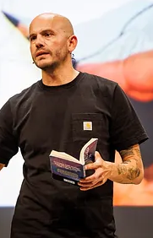 ***“I want to write for those who find themselves lost sometimes and try to show we all are. But that whatever happens, there is hope. Always..”*** By Matt Goodfellow

Matt was supposed to be a rock star and from the age of 13 was playing in bands and writing songs. When the music career failed to take off, Matt became a primary school teacher and the songs became poems. Matt’s writes poems about three things: his life, lives that he’s seen and stuff he makes up. Many of Matt’s poems focus on navigating the peaks and troughs of life often touching on his own troubled upbringing. Matt Goodfellow has experienced recent success with his book called ‘The Final Year’, about a young boy’s experiences of Year 6. A much recommended for children and adults alike. We love

**Encouraging Reading at Home -TOP TIPS**

Reading doesn’t just have to be about books. Words are everywhere! Encourage children and parents to read whilst out and about; this can be less daunting than sitting down with a book and also address the issue of finding time. Suggest reading signs (such as shop signs, road signs) and notices (or spotting letters) when out and about or around the home, or sharing the menu with your child when out for a meal, looking at a magazine together, reading information leaflets about places or information boards on daytrips.’.

**Online Reading**

 We are also lucky enough to have an online reading platform called OXFORD READING BUDDIES. We know that some children and adults do not enjoy reading online, but if sharing the experience, it can still be a fun experience. E-books can provide a different way to engage with reading; some people may feel more comfortable with a digital device than a physical book.

**Read THIS Newsletter together:**

Share the information about new books and authors together. As well as taking part in the literacy days. Read the poem and try and learn it. Send feedback to the English team about reading that you would like more information on. Tell us what you would LIKE to see in this leaflet.

**Book Talk at mealtime**

Allow Book Talk time at mealtimes, even if it is just once a week. Everyone at the table talks about something they have read that week. It might be a newspaper article, a timetable, leaflet, work document……the list is endless. Encourage questioning about what has been read and lots of encouragement as to where their reading may head next.

**Celebrating Reading at home**

Each month, we try and share our literary days with you. We hope you celebrate these days at home with your children. Please share any work with your class teacher to earn some extra Dojos.

|  |
| --- |
| **Summer Term** |
| May |
| 9th is Make a book day |
| 12th is Limerick day (Read or write) |
| June |
| 10th is Ball Point Pen Day |
| 21st is National Writing Day |
| July |
| 4th is Alice in Wonderland Day |
| 30th is Paperback book day |

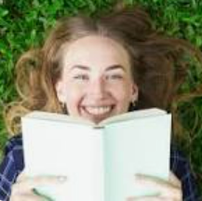**Fun facts about Reading**

**Reading makes you a happier person**

Since a good book can work wonders in alleviating stress and depression, it’s pretty obvious why people who read more are more self-confident and happier.

By surveying more than 4,000 adults, the University of Liverpool concluded that readers are happier, less stressed, cope better with challenges, and have more close friends than non-readers. Isn’t that a fun fact about reading?

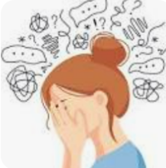**Reading reduces stress**

We’ve all felt that ourselves. Reading a good book after a long and stressful day works wonders on our state of mind. Studies have actually shown that leafing through a book can be up to 600% more efficient in relieving stress than playing a video game and 300% more efficient than going for a walk. Now that’s a fun fact about reading.

According to a 2009 study conducted by the University of Sussex, only 6 minutes of reading can reduce stress levels by up to 68%. It is quicker and works better than many other stress-lowering methods like listening to music or drinking a cup of tea.

**Poem of the Term**

Reading poetry with children brings such joy. There are many positives to reading poems with your children, including helping them develop their speaking confidence and introducing them to new vocabulary and experiences.



**I Opened a Book By Julia Donaldson**

**I opened a book and in I strode.**

**Now nobody can find me.**

**I’ve left my chair, my house, my road,**

**My town and my world behind me.**

**I’m wearing the cloak, I’ve slipped on the ring,**

**I’ve swallowed the magic potion.**

**I’ve fought with a dragon, dined with a king**

**And dived in a bottomless ocean.**

**I opened a book and made some friends.**

**I shared their tears and laughter**

**And followed their road with its bumps and bends**

**To the happily ever after.**

**I finished my book and out I came.**

**The cloak can no longer hide me.**

**My chair and my house are just the same,**

**But I have a book inside me.**