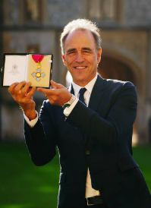 ***“I have a great belief in not doing anything unless I'm passionate about it.”*** By Anthony Horowitz

Anthony Horowitz’s most famous children’s books are arguably the Alex Rider novels, noted for enthusing and inspiring a new generation of younger boys into reading again. The books did make it to screen, however only one film was made. The book series spans 12 novels. But his quote is one that really reflects why he is such a great author. His passion for writing enthralling and captivating children’s book is clearly a deep passion. So, we must always find those passions in life and who knows what we could achieve!

**Parents support with Reading**

Drawing on evidence from extensive academic and peer-reviewed research, BookTrust's new resource provides a deeply compelling case for how supporting children to read has the potential to transform children's life chances and give them the best start in life. Whilst the evidence bases to support the benefits of reading is extensive and growing, wider society often focuses on how reading can improve children's literacy and academic performance. By publishing its new resource, BookTrust aims to showcase the numerous and equally important ways in which reading can positively impact a child's life.

The evidence also highlights how children from disadvantaged backgrounds stand to gain the most from developing a reading habit and underpins why BookTrust's new strategy focuses on providing extra support to these families through its wide range of books, resources and programmes.

The information can be found here: <https://www.booktrust.org.uk/news-and-features/news/news-2023/how-does-reading-benefit-children/>

In the resource, BookTrust has grouped the benefits of reading into four core themes setting out how children who read are more likely to:

***Overcome disadvantage caused by inequalities***

***Be healthier and happier children with better mental wellbeing and self-esteem***

***Do better at school and make more progress across the curriculum***

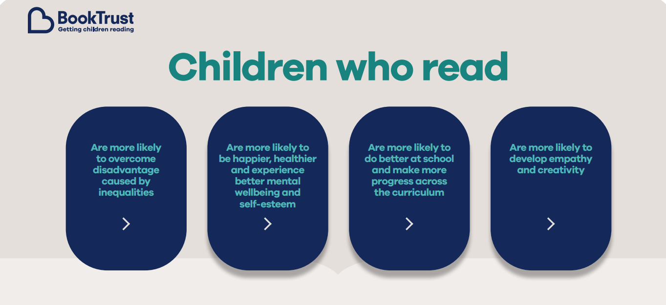***Develop creativity and empathy***

**‘The Final Year’ by Matt Goodfellow**

Life can be tough in your last year of primary school. Tests to take,

preparing for the change to high school. Nate is ready for it all, knowing his

best friend PS is at his side - they’ve been inseparable since Nursery.

But when they are put in two different classes and PS finds a new friend in

Turner, the school bully, Nate's world turns upside-down. As he struggles to

make sense of this and forge new friendships, he’s dealt another blow when

his youngest brother, Dylan is rushed into hospital.

His new teacher, Mr Joshua, sees a spark inside of Nate that’s lit by his love

of reading and writing and shows him how to use this to process what’s

going on. But with so much working against him, and anger rising inside him,

will this be enough?

**This book is suitable for Years 5 and 6.**

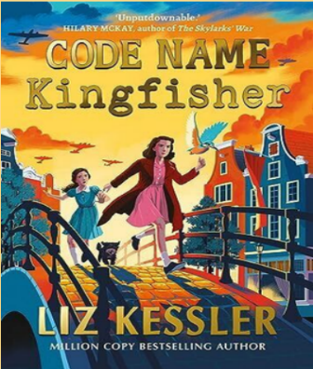

**‘Code Name Kingfisher’ by Liz Kessler**

Nazi-occupied Amsterdam in 1942, Hannie joins the Resistance. In the modern day, Liv is trying to cope with bullies at school.

Historical fiction of the highest order – heart-breaking, thought-provoking and vital.

Liz Kessler inspired our Year 3 and 4 Library nook name ‘Kessler’s corner’.

**This book is suitable for Years 4, 5 and 6.**

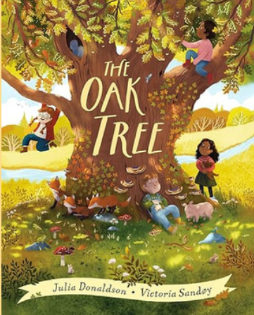**‘The Oak Tree’ by Julia Donaldson**

Watch a thousand years unfold in the life of one magnificent tree! A thousand years ago, a tiny acorn fell to the ground. As the years pass, it grows . . . and GROWS into an enormous oak tree! As the centuries sweep by, children play games around the tree. Families dance about it. A fleeing king even hides inside its hollow trunk! The tree gives food and shelter to a host of animals, from squirrels and badgers to birds and beetles. After a thousand years, the ancient tree finally falls in a storm - but a new acorn sprouts, and the cycle of life begins all over again.

**Recommended for children from EYFS upwards.**

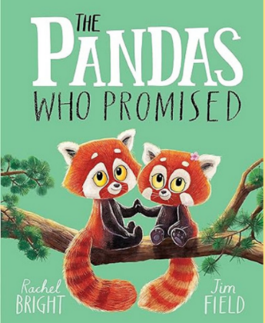**‘The Pandas Who Promised’ by Rachel Bright.**

High up on a misty mountainside, red panda cubs Popo and Ketu live happily with their mama. As the sisters grow, they promise that they will ALWAYS stay close to home. But while Popo is content to stay in the family's cosy treetop nest, bold Ketu dreams of excitement and exploration. And so when Ketu creeps off down the mountain in search of adventure, Popo must make a choice: will she keep her promise to Mama, or look after her sister?

**Suitable for children in EYFS upwards.**

**Celebrating Reading at home**

Each month, we try and share our literary days with you. We hope you celebrate these days at home with your children. Please share any work with your class teacher to earn some extra Dojos.

|  |
| --- |
| **Spring Term** |
| January |
| World Braille Day – 4th January |
| National Storytelling week - 27th January to 4th February |
| February |
| Time to Talk Day - 2nd February |
| International Book Giving Day – 14th February |
| March |
| World Book day – 7th March |
| International Woman’s Day 8th March |

**Please have a look at this website. There are lots of helpful articles to read, that offer support and guidance for reading.**

[**https://home.oxfordowl.co.uk/reading/reading-at-home/**](https://home.oxfordowl.co.uk/reading/reading-at-home/)

**Poem of the Term**

Reading poetry with children brings such joy. There are many positives to reading poems with your children, including helping them develop their speaking confidence and introducing them to new vocabulary and experiences.

**‘The Pied Piper of Hamelin’ by Robert Browning**

Your child might be familiar with this story, but it’s a good poem to read together and try to work out what is happening. You can talk about how Browning brings the narrative to life by appealing to all the senses, from sound (‘you should have heard the Hamelin people…’) to sight (‘the Mayor looked blue’) and by using rhyme (‘bustling / hustling / clattering / chattering’).

**The Pied Piper of Hamelin (an extract)**

You should have heard the Hamelin people

Ringing the bells till they rocked the steeple.

Go," cried the Mayor, “and get long poles!

Poke out the nests and block up the holes!

Consult with carpenters and builders

And leave in our town not even a trace

Of the rats!”-- when suddenly, up the face

Of the Piper perked in the market-place,

With a, “First, if you please, my thousand guilders!”

A thousand guilders! The Mayor looked blue;

So did the Corporation too.

For council dinners made rare havoc

With Claret, Moselle, Vin-de-Grave, Hock;

And half the money would replenish

Their cellar’s biggest butt with Rhenish.

To pay this sum to a wandering fellow

With a gypsy coat of red and yellow!

“Beside," quoth the Mayor with a knowing wink,

“Our business was done at the river’s brink;

We saw with our eyes the vermin sink,

And what’s dead can’t come to life, I think.

So, friend, we’re not the folks to shrink

From the duty of giving you something for drink,

And a matter of money to put in your poke;

But as for the guilders, what we spoke

Of them, as you very well know, was in joke.

Beside, our losses have made us thrifty.

A thousand guilders! Come, take fifty!

The Piper’s face fell, and he cried,

“No trifling! I can’t wait! Beside,

I’ve promised to visit by dinnertime

Bagdad, and accept the prime

Of the Head-Cook’s pottage, all he’s rich in,

For having left, in the Caliph’s kitchen,

Of a nest of scorpions no survivor -

With him I proved no bargain-driver,

With you, don’t think I’ll bate a stiver!

And folks who put me in a passion

May find me pipe to another fashion.”

“How?” cried the Mayor, “d’ye think I brook

Being worse treated than a Cook?

Insulted by a lazy ribald

With idle pipe and vesture piebald?

You threaten us, fellow? Do your worst,

Blow your pipe there till you burst!”

